# Debugging Exercises

Name: Jordan Wesson  
Campus: Sydney

## Exercise 1: Run the Debugger

Run the Debugger Upload a screenshot of Visual Studio running in debug mode.  
Insert Screenshot.

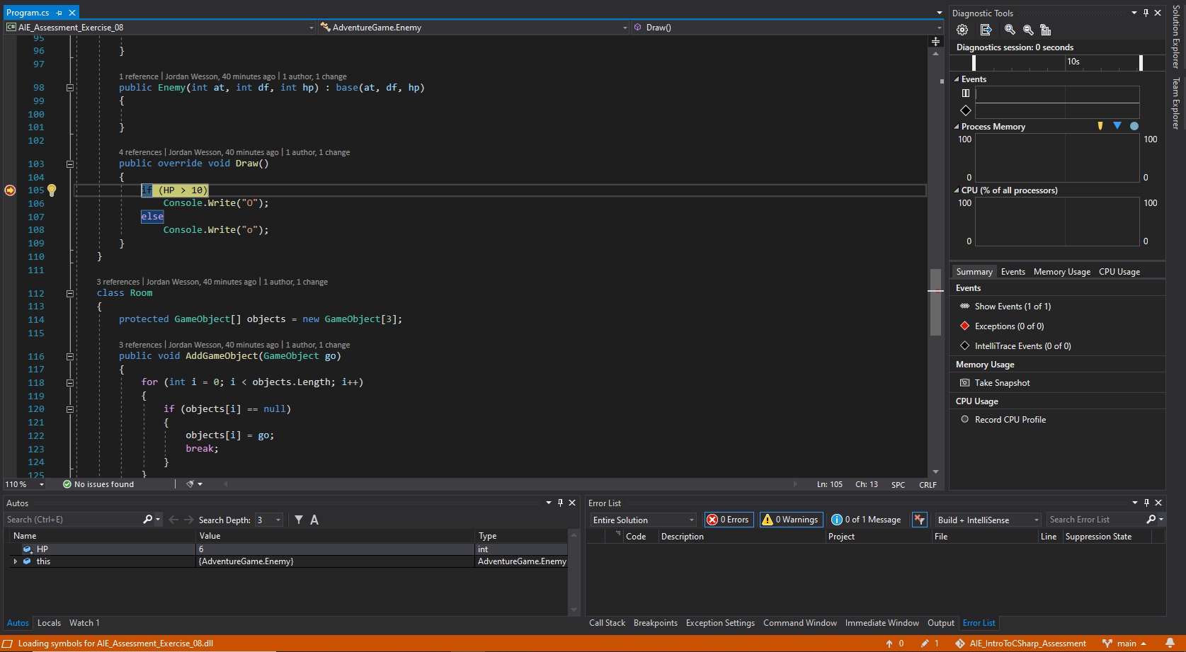

## Exercise 2: Compiler Errors

Upload a screenshot of 3 different compiler errors. Write a brief description of what each error means.

|  |  |
| --- | --- |
| **Screenshot** | **Error Description** |
|  | Missing a ‘;’ at the end of the command. |
|  | Not closing off the if statement. |
|  | Not defining variable type.  ‘int at‘ required in parameter list |

## Exercise 3: Reference Material

List at least one website that provides material to aid you in understanding the C# Language.

Microsoft C# Documentation

https://docs.microsoft.com/en-us/dotnet/csharp/

## Exercise 4: Using the Debugger

Upload a screenshot showing.

* A breakpoint



* A variable watch

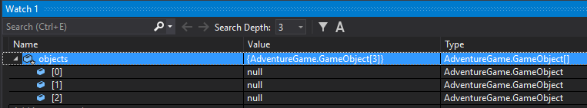

* The call stack

